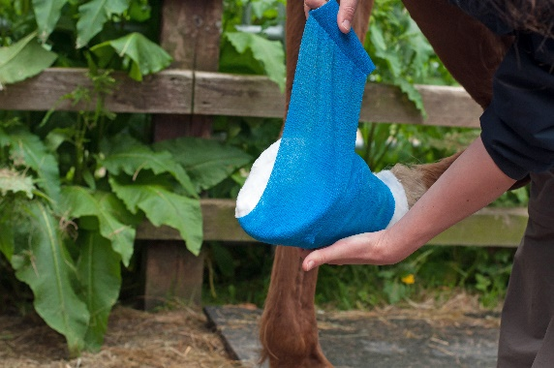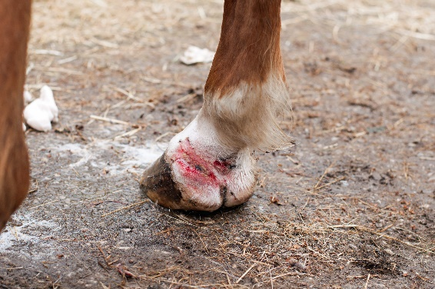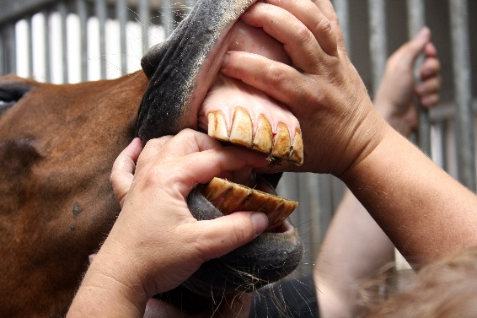

Wanganui Vet Services Equine offers the following services:

- 24-hour emergency care
- Advanced dental work, including nerve blocks and extractions
- Mare reproductive scanning, insemination, etc
- Foal branding and registrations
- Event vetting, as for racing, harness racing or endurance rides
- Lameness work-ups with nerve blocks, ultrasound and Xrays
- Vaccinations, worming and nutritional advice
- General health care from foals to geriatric horses. Everything from ophthalmic, respiratory and gut, skin issues

