

VETCARE GRAZING NEWSLETTER SPRING 2017

NEWSLETTER SPRING 2018

Website

Vetcare Grazing has an upgraded website and face book page. Check it out for news and views; grazing available; bulls for hire and sale; stock and feed for sale etc. Feel free to add comments and use it for advertising.

Google Vetcare Grazing and you will find it
or
https://www.wgvets.co.nz/vetcare-grazing-scheme

Bigger Heifers do Produce More

Dairy heifer replacements are the future of the herd, they are generally of the highest genetic merit but need to be grown adequately to allow their genetic potential for milk production to be fully expressed.

A recent study by researchers from LIC; Massey University and Lincoln University and reported at this years NZ Veterinary conference investigated the relationship between live weight from three to 21 months of age and milk volume, fat and protein yields in first lactation dairy heifers.

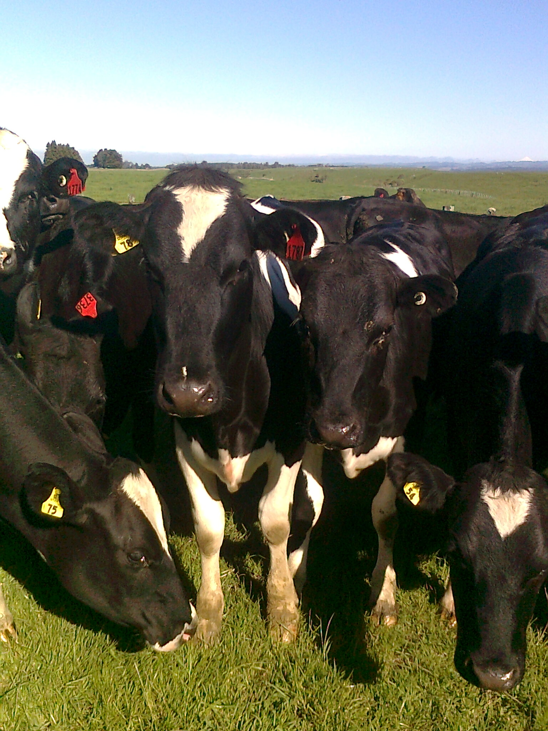

Live weight records from 189,936 New Zealand dairy heifers that were
spring-born (June to December) between 2006-07 and 2013-14 dairy
seasons were extracted from the Livestock Improvement Corporation
(LIC) database.

Calving date and milk production records were also extracted from
the LIC database and heifers were selected that calved at approximately
two years of age (21–29 months of age) between June and December

Results showed that live weight from three to 21 months of age had significant positive relationships with first lactation volume, fat, protein yields. Heifers that were heavier at 6, 12, 15, 18 and 21 months of age produced more milk, fat and
protein compared with heifers that were lighter.

The relationship between LWT and milk solids yield for FxJ heifers is depicted in (Figure 1) below. It illustrates that the relationship is linear when heifers were three months of age, and curvilinear when heifers were six months
of age and older. The milk solids response to increasing live weight is greater in lighter heifers than the heavier heifers aged six to 21 months of age, with no observed plateau within the LWT range studied. Similar relationships existed for the other breed groups, F; FX; J F and J with the majority having similar effects.

Figure 1. The relationship between live weight at 3, 6, 9, 12, 15, 18 and 21 months of age (m) and milk solids yield in1st lactation Holstein-Friesian-Jersey crossbred (FxJ) dairy heifers. The live weight range for each age is the range of live weights observed for that age group.

The mean LWT of FxJ heifers was approximately 300kg at 15 months of age, and 420kg at 21 months of age. Heifers that were 280kg (20kg lighter than average) produced 167L less milk than the average 15-month old FxJ heifer ( Figure 2). Heifers that were 320kg (20kg heavier than average) at 15 months of age,
produced 160L more milk than the average 15-month-old FxJ heifer. Similar relationships existed for 21-month-old FxJ heifers and for heifers of the other breed groups.

Figure 2. First lactation milk volume (L) and milk solids (kg) yield response to a 20-kilogram increase in live weight (LWT)
from 280 to 300kg, and 300 to 320kg at 15 months (15m), or 400 to 420kg, and 420 to 440kg at 21 months of age (21m)for Friesian-Jersey crossbred (FJ) heifers

In summary: there was a positive relationship between live weight and milk, fat and protein yields in first lactation dairy heifers. Heifers that were heavier produced more milk than heifers that were lighter, regardless of breed group. The milk production response to an increase in LWT was greater for lighter heifers than heavier heifers. Dairy NZ state that there is no known benefit from exceeding target LWTs however, results from this present study do not support this finding.

Despite increased interest in improving heifer growth, the recent data showed that 65% of 22-month-old heifers in NZ were more than 5% below target so there is huge potential to grow heifers better and to increase production in the national herd.

Over the years heifers managed by Vetcare Grazing have on average been above the mean live weights determined for the different breeds in this study due to the Company engaging top graziers and having payments based on weight gain incentive so both the dairy farmer and grazier are winners.

The Fatty Udder Syndrome

In order for heifers to be heavier during the pre-calving period, they must grow faster. Rapid growth prior to puberty has been shown it can give rise to excessive fat deposition in the mammary gland; termed “Fatty Udder Syndrome” . The fatty udder can result in less mammary gland secretory cells and reduced life time production

However, there is a lot of conflicting evidence that rapid growth rates during this period will affect subsequent milk production. Some studies mainly from overseas showing high weight gains having a negative impact on the growth of mammary secretory tissue generally used high energy diets e.g. grain based.

Therefore, in NZ, with high protein pasture-based systems where energy is the first limiting factor in the diet, “fatty udder syndrome” is unlikely to occur and be a problem unless pasture is substituted with an excessive amount of high energy feed e.g. too much grain given in the critical pre-puberty period. Feeding calves grain pre and post weaning is not an issue and is necessary for rapid rumen development.

Results from the study reported above do not provide evidence that heifers
were “too heavy”, and hence grew “too fast” and had their production limited on NZ pasture-based diets.

Heifer Fertility

Dairy NZ research is finding out more and more that genetic fertility is having quite a bearing on in calf rates and lifetime fertility performance. Over 25 years of recording pregnancy test results we have shown that certain lines of heifers tend to have higher empty rates than other lines year after year despite the same ratio of bulls and sometimes higher ratio of bulls.

We have found that Jersey heifers statistically have higher empty rates than FXJ and F heifers. Ayrshire heifers also have higher empty rates. A lot of the differences is most likely genetic based.

A notable finding from the Dairy NZ research to date is that high-fertility breeding value (BV) heifers attain puberty 25kg lighter than low-fertility (BV) heifers despite identical growth rates. Accordingly, Dairy NZ are planning to scale up the measure of this trait using larger numbers of animals across commercial herds to perform a more robust genetic evaluation.

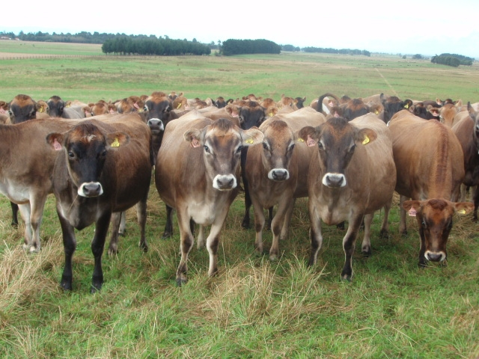

Also, research has found that there are differences in the survival rate of embryos in the first seven days in utero. Work is ongoing focusing on new management and genetic solutions that may be used to keep embryos alive to achieve better herd fertility in cows and heifers.

We commend this research as it has been frustrating over the years having to report higher than expected empty rates despite good bull; health and feeding management.

Facial Eczema

A study involving 1046 dairy heifers in 2016 across farms in the north island was carried out to determine the effects of FE on weight gain; fertility and death rate in replacement dairy heifers

A measure of liver GGT concentrations above 300iu/L was used to determine heifers that had been affected by severe facial eczema.

The difference in weight between calves that sustained FE damage and calves that did not in 2016 was 9.15, 9.89,10.4 and 15.3kg at 9, 12, 15 and 22 months respectively (all p<0.001).

There was no difference in death rate between FE affected and non-FE affected calves between April 2016 and June 2017.

There was a difference in empty rate between FE affected and non-FE affected calves (5.5% vs 8.6%) .

There was a trend for FE affected animals to take longer to conceive than non-FE affected animals (16 days vs 14 Days)

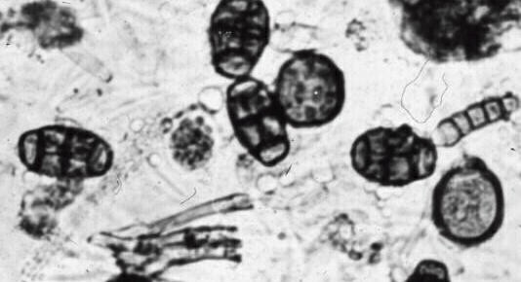

Other studies have shown a significant effect on production when stock have been affected by FE

Last summer/autumn was one of the worst FE seasons we have encountered and a few graziers despite taking precautions still had some stock affected. Recently I sent all graziers detailed information entitled “Control Measures for Facial Eczema” that can be used this coming season to put an effective programme in place to prevent valuable young stock getting FE. Please don’t hesitate to discuss with the grazing team or myself.

Mycoplasma

As available testing is not reliable to accurately identify infected individual animals; the Vetcare Grazing team is reliant on and is doing on going due diligence to limit the risk.

The only commercially available test is the PCR which only identifies infected animals shedding the bacteria at the time of testing; however, the majority of infected animals are not shedding so false negatives occur therefore it’s not practical to use.

In regard to the angus and jersey bulls we are supplying this spring. they come from 4 farms that we have dealt with for many years. We have detailed knowledge of their farming practices and stock movements on and off the farm. We know that no stock has come from infected properties and no stock directly or indirectly from the South Island where the source of the infection arose.

The jersey bull calves are purchased from dairy farms from Taranaki and Manawatu that are more or less closed herds, and all have had negative milk tests. The angus bulls are home bred.

Although there has been a huge amount of information advising avoiding direct contact with neighbours’ stock which is best practice. At a recent meeting MPI stated that none of the infected properties diagnosed so far have resulted from introduction from neighbours’ stock over the fence. Every new infected herd diagnosed has resulted from introduced infected stock.

Mycoplasma is not that easy to spread from one animal to another. It requires close direct contact over time which gives us hope that eradication will be successful

Bulls

There has been a big demand for our bulls this year, but we still have a few well grown 1yr and 2yr Angus and 2yr Jersey bulls for sale suitable for tailing up herds and a few 1yr and 2yr Jerseys available for hire.

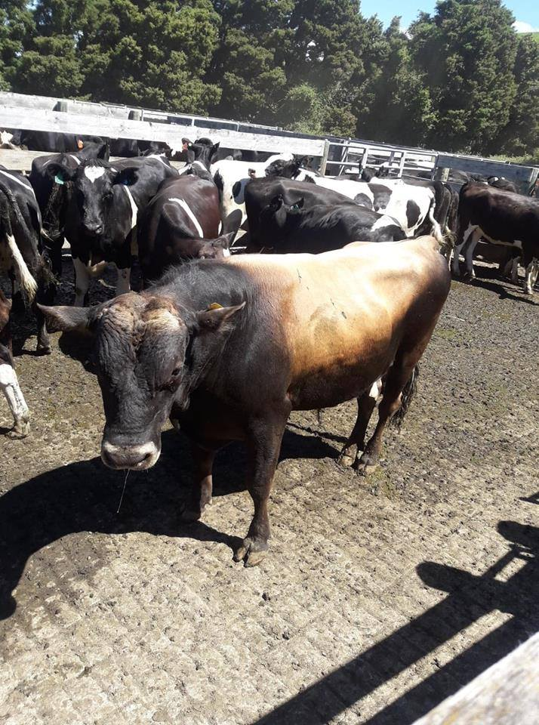

If you are interested, contact John Pickering 0274429608

Vaccine Storage

Many vaccines need to be stored in a refrigerator usually between 2-8 degrees C to maintain their potency and immunogenicity. Often vaccines are not stored in the refrigerator or when taken out of the refrigerator; not put in a chilly bin with ice packs to keep the vaccine at the required temperature when in use. Particular in the summer months when temperatures are higher vaccine efficacy will rapidly decline and perhaps become ineffective well before the expiry date if not stored at the correct temperature.

A recent British study recorded the internal temperatures of 19 farm refrigerators over a 7-month period. The study concluded that each refrigerator recorded either above or below the recommended temperature of 2-8 degrees C and in a significant number of refrigerators the temperature was outside the required range for long enough to affect the vaccine’s potency

It’s a good idea to place a digital thermometer inside the refrigerator and monitor the temperature regularly and if not correct do something about it.

Blood Poisoning 10 in 1 Vaccine

To avoid sudden death from blood poisoning in your heifers we recommend using Covexin 10 in 1 rather than 5 in 1’s; 6 in1’s and 7 in1’s and a new 8 in 1 that are on the market. It is good insurance to protect valuable replacements.
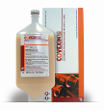

Covexin 10 in 1 protects against 10 important Clostridial blood poisoning bacteria including Clostridial sordellei and perfringens type A. Both can cause sudden death in calves and older cattle without warning which we see from time to time

Sordellei and perfringens type A cause rapid sudden death e.g. a heifer can be bright and well in the morning yet dead by evening. It often occurs when heifers are being very well fed on high quality feed. Heifers under stress are also more likely to die from these Clostridial infections.

There are many sudden cattle deaths every year in NZ; most are never examined.
and diagnosed. It is my bet that a lot of them are due to blood poisoning and the use of 10 in1 vaccine would prevent a lot of them.

I urge you to use the 10 in 1 (covexin 10) vaccine in your replacements. It is a cheap cost-effective vaccine so its good insurance to use it. Two vaccinations 3 – 6 weeks apart followed by annual boosters will give complete protection. Tick the box in our contract.

Weaner Grazing

Already there has been more demand for weaner grazing this spring than space available. It is not easy finding top quality grazing that is suitable for growing weaners up to the required standard.

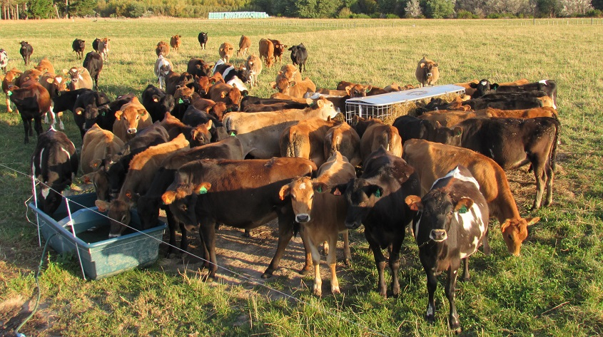

To all our graziers; please give us names of top farmers that might be interested in grazing weaners this year and we will contact them or if you have some space your self please let us know. Appreciate it.

All the best from the grazing team.

John Pickering
Veterinary Advisor
Vetcare Grazing

