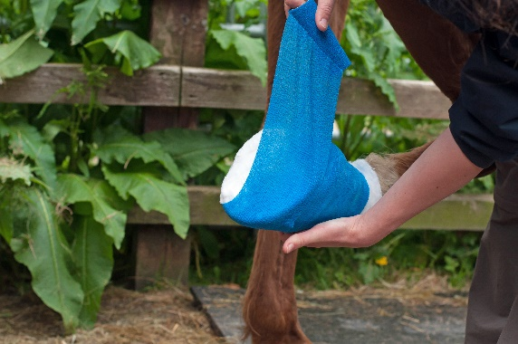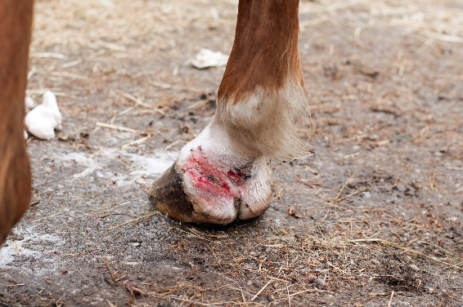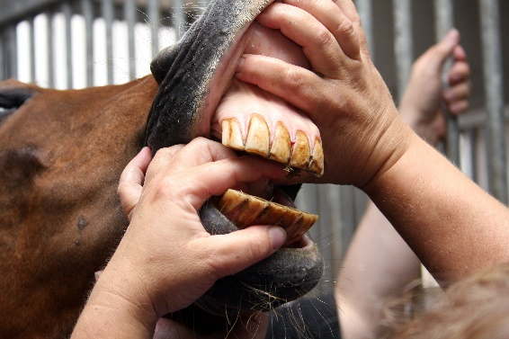

***Areas of Experience***

**• ophthalmic disorders  
• skin conditions  
• respiratory disease  
• trauma and wound care  
• colic and gut disturbances  
• nutrition and body condition management  
• lameness work-ups with nerve blocks and Xrays  
• first-opinion foal care  
• mare reproductive health (RFMs and general health)  
. mare insemination  
• vaccination and worming advice  
• vet work at flat races, trotting races and endurance rides**

***Wilna is a keen endurance rider and is looking forward to getting back into the sport again soon***