

VETCARE GRAZING NEWSLETTER SPRING 2017

NEWSLETTER

It’s been a while since we sent out a newsletter to our dairy farmer clients; graziers and bull farmers; so here it is; to give you an update as to what is happening in the Vetcare grazing world. John Pickering who is now part time has volunteered to be the editor and to put together a newsletter more regularly.

TWENTY FIVE YEAR ANNIVERSARY

HISTORY

This year is the 25th year since Vetcare Grazing started so here is a bit of history that you may find interesting.

John Pickering started the Vetcare business twenty five years ago in 1992 in response to a real need for a professional heifer grazing business. Back then there were a lot of heifers being grazed privately in the area; no contracts in place; no plan; no targets; flat rate and more often than not poorly grown heifers. There were a lot of disputes back then and John as a Dairy Vet got involved in trying to help resolve some of these.

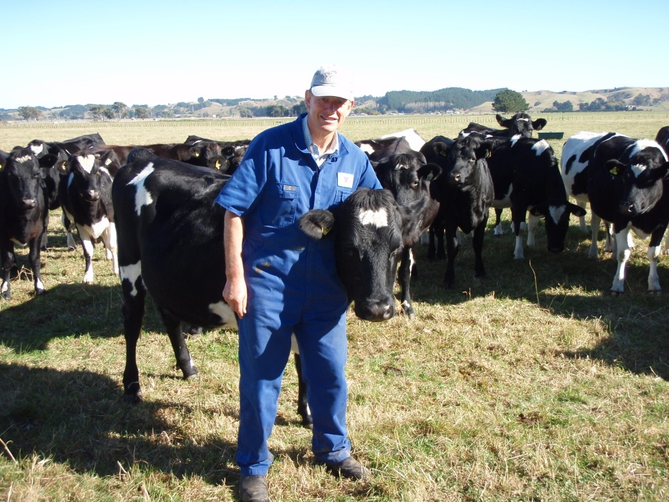

After a lot of thought John decided the best answer was for the Veterinary practice to get involved; so he started a professional grazing business including putting contracts in place. The service included regular monitoring; weighing; reporting; target weights set; animal health; mating and nutrition managed; weight gain incentive payments and certified bulls supplied. The model has worked.

In the first year only 200 heifers were grazed by one grazier so the future requirements could be fine tuned. Numbers rapidly increased as did the number of graziers so by 2017 there are now over 7000 May to May heifers being grazed by 27 graziers in Wanganui; Rangitikei; Manawatu and an increasing number in Hawkes Bay. It was up to 9000 before the dairy down turn but is steadily increasing again now. Weaner and winter grazing started in 1997.

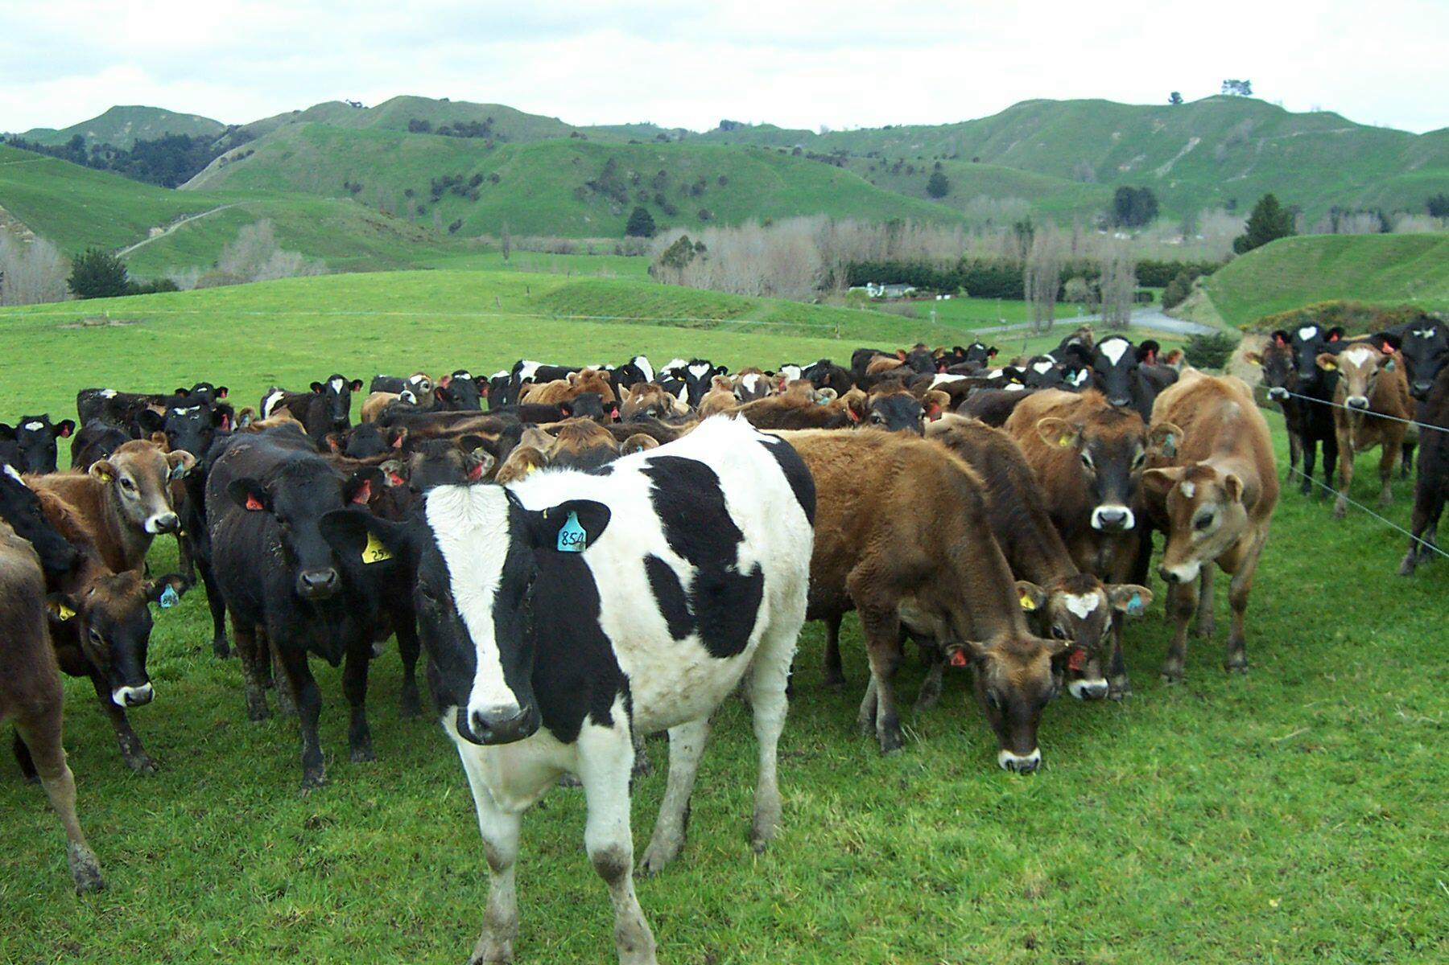

In parallel the Vetcare bull business started in 1993. John remembers only too well talking to Rob Poole back in 1993 who said that he would only send heifers to graze if Vetcare Grazing could supply bulls. That comment was the catalyst to start a bull hire business and to find a farmer that was prepared to grow and supply bulls to specification.

Today the business has 4 specialist bull farmers; Craig Skou; Paul Geurtjens and Hamish Carlson in Hawkes Bay supplying jersey bulls and John Stewart supplying angus on contract to specification.

Along side the heifer grazing and bull hire businesses it must be mentioned that Grange transport and Brendon Molan the owner and more latterly his manager Steve Allwright as well have supported the business as our preferred carrier since the inception carting heifers and bulls without any fuss or bother. Their record for stock health and safety has been exceptional. We thank them for 25 years of dedicated service.

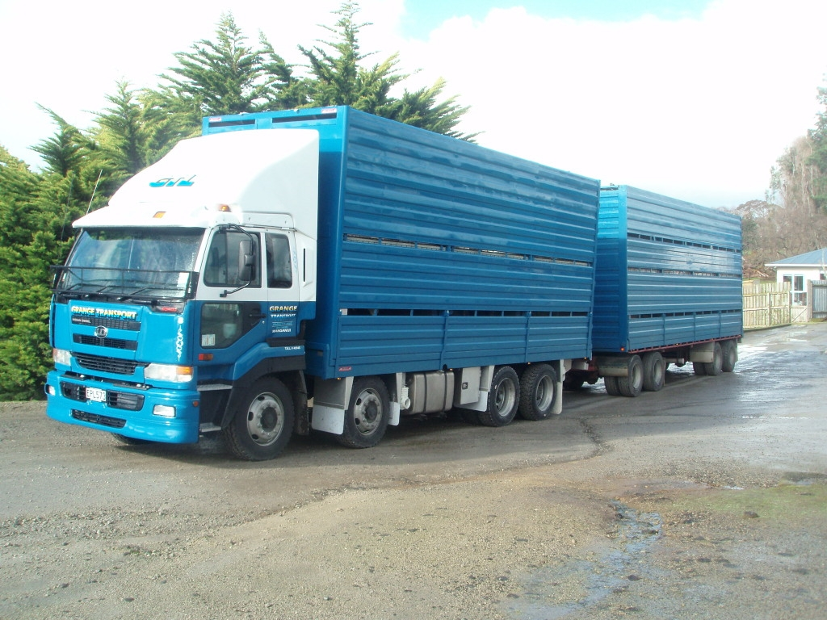

LOYAL CLIENTS

There have been many loyal dairy farmer clients; graziers and bull farmers involved over the last 25 years that have enabled the business to grow and become a success. We are indebted and thank everyone that has been involved both present and past. The business is now recognized nationally as a leader in the field and we are very proud of that

Looking back through the records there are many dairy farmers that have been with us over 10 years or more and a few over 20 years soon after we started that we’d like to name and thank personally for their loyalty and business over a very long time .

Our longest serving client is Roger Landers who started with us in 1993 and has sent heifers to us every year since then. Rob Poole and Hugh Wilson also started in 1993; stayed for a few years then left for a time before returning in recent years.

In 1994 Pam and John O’Dea and Maurice Hurley came on and have been with us since then and Steve Poole also came on then; went away and came back in recent years

In 1995 John Fischer and Jason Hurley came on and have been with us every year since.

Our longest serving graziers are David Newman who started in 1994 and Peter Cranstone in 1995 that have year after year reliably grown consistently good heifers despite the weather and the changing growing conditions.

STAFFING

As the business grew from 1992 with heifer numbers going up John needed help so Jamie Anderson who had been a dairy farmer previously joined the business in 1997 and along with the day to day work put his marketing skills to work to help grow the business further.

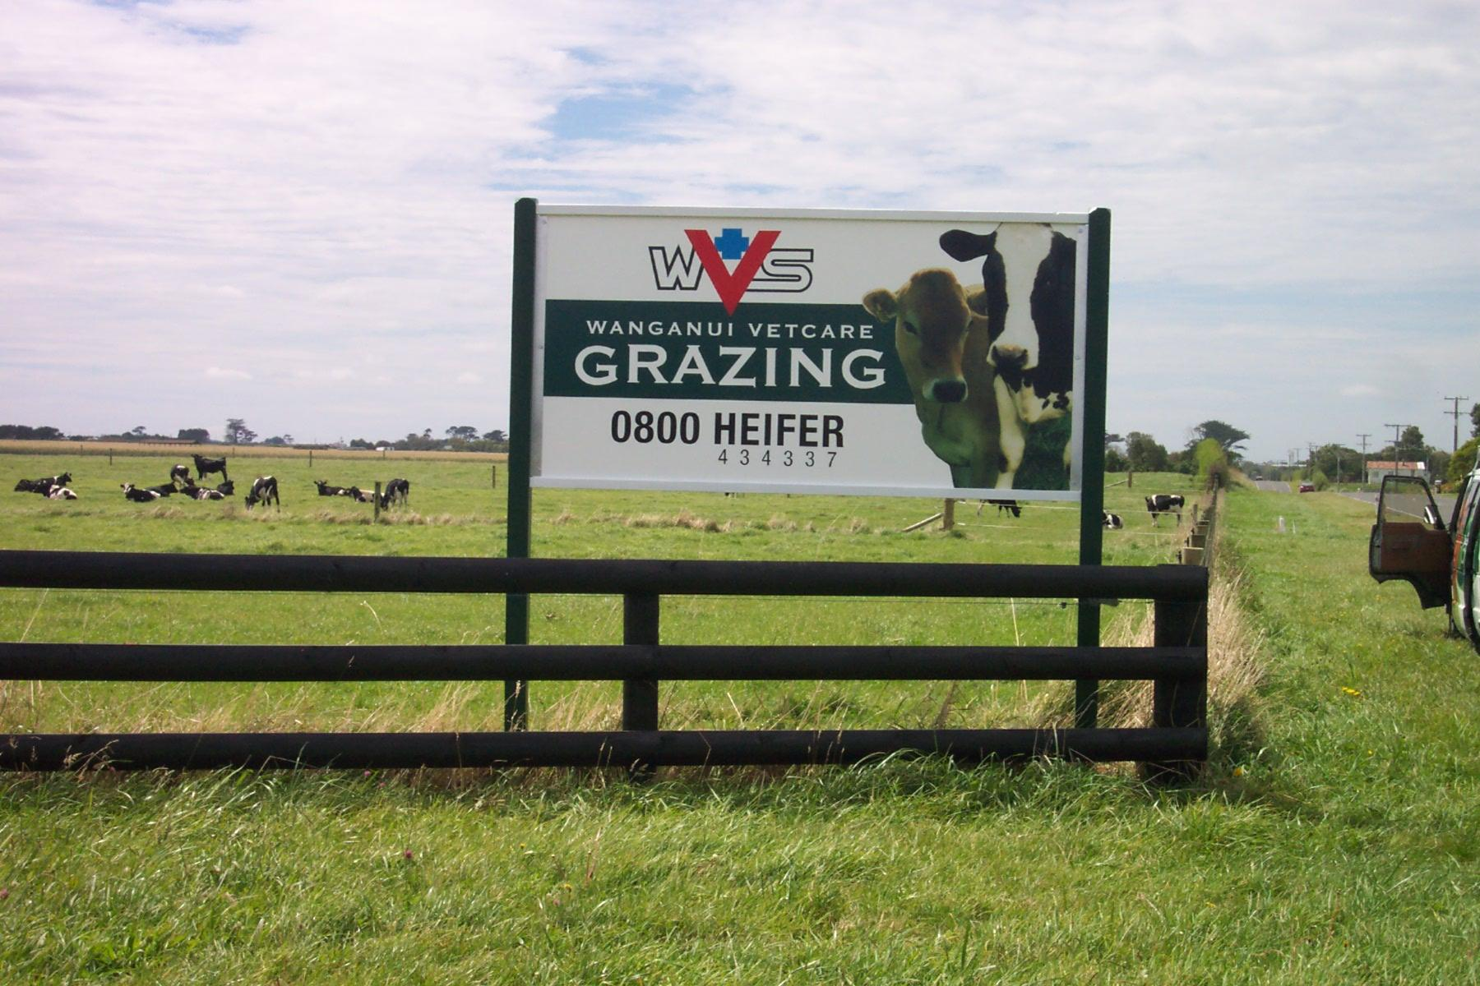

John and Jamie managed the business on their own until 2006 when further growth required a 3rd person join the team.

That person was and still is Kay McGillivray who also had a dairy farm background and used that experience to soon make a positive difference along with her passion, enthusiasm; jest for hard work and attention to detail.



Further growth in the business required more help and Matt Ratcliffe joined the team in a part time capacity in 2013 as a weigh technician.

At the end of 2014 John Pickering decided it was time to cease his full time employment in the Veterinary practice and Vetcare Grazing as he and his wife wanted to move to Hawkes Bay to be closer to family. He has continued working for the grazing business in a part time role; still managing the bull hire business; preparing the mating programmes; some work on the HB grazing blocks and being available in a consultancy role helping and advising the rest of the team as required.

Part way through 2015 John Guiniven was employed as the new Vetcare Grazing manager.

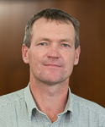

John also has a dairy farming background previously managing a very large dairy farm in North Canterbury including gaining experience on how to combat the extreme weather patterns down there. John has further developed the business since coming on board by introducing beef heifer and dairy heifer autumn calving grazing contracts in response to a demand. He has more ideas for the future

Recently Jamie Anderson tendered his resignation after 20 years of loyal service and is going to be replaced by Blake Cameron who has just been appointed to the team. Blake who qualified with a Bachelor of Agriculture Science degree from Massey University has an agricultural back ground particularly in dairy farming.

Blake is a Taranaki product; his father Hugh Cameron a well know Taranaki dairy farmer was one of our valued clients sending heifers to graze and hiring bulls from us for many years. Blake made mention in his CV that with his parents using Vetcare Grazing for many years; he knows first hand the pride and the quality the team take in the business and he knows he would thrive being part of the successful team. We welcome Blake to the team. Blake commences work in the middle of October.

JAMIE ANDERSON’S RESIGNATION

After 20 years of loyal service Jamie has decided to retire. Unfortunately a shoulder injury followed by a spinal injury requiring surgery less than two years later made Jamie realise that his little body is no longer as reliable as it was.

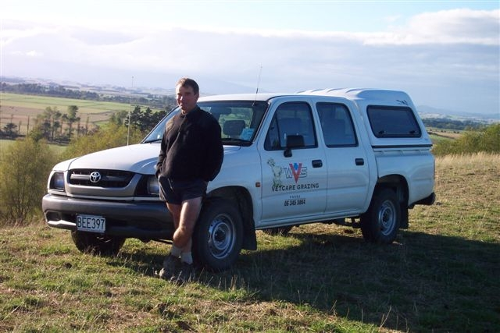

Jamie has summed up his time working with Vetcare Grazing in his own words as follows

“When I left my dairy farm and joined Vetcare Grazing I embarked on what I thought might be a five year job. Well, the challenges, the rewards, the people and the industry have all provided a wonderful transition from the hands on part of dairying with the result that it has been a 20 year job instead.

Heifer numbers have gone up and down, clients have come and some gone, grazing blocks have gone further afield and the dairy pay-out has fluctuated hugely; but during all these challenges the profile of Vetcare Grazing gradually strengthened and grew. In my role as the marketing person I have had the privilege of meeting and working with some great people from as far afield as Waitara in the north Taranaki, Putararu in the Waikato, Levin and Hawkes Bay, plus all the country within.

I describe my marketing as ‘cup of tea marketing’, the aim being to build relationships first and the business will follow. With this approach I was given cups of tea and lunches by so many clients, got to know them, their families and their requirements. I am very grateful to all these people for their generosity and their trust and I want to thank everyone for the support over many years.”

We wish Jamie all the best in retirement and thank him for his dedicated and loyal service over many years.

THE SEASON SO FAR

I know we all agree it has been one of the wettest periods that we have experienced on record from autumn to spring. It has made feeding stock and getting grass down mouths before its pugged very difficult particularly on the wetter farms with a clay base. Talk about the environment!!. A lot of graziers having to resort to feeding silage out of racks or break feeding crop to supply required nutrition. Grass is growing well now with warmer temperatures and as it gets drier heifers are being well fed and growing well coming up to mating. A rising plane of nutrition through the mating period will help in calf rates.

SELENIUM

Right across the grazing blocks; selenium levels have been checked by blood testing a sample of heifers. Due to the very wet conditions some properties have had lower selenium levels than usual and those properties in the deficient range have had to supplement with selenium. Deficient levels can affect growth rate and reduce fertility.

MULTIMIN

MULTIMIN is a balanced injectable trace mineral supplement of zinc, manganese, selenium and copper. These minerals are now recognised to play vital roles in the control of oxidative stress in animals.

Trace minerals are essential for a wide array of physiological functions related to growth, reproduction and immunity in livestock. There is also an increased need for trace elements during mating.

For example, manganese is now recognised as hugely important for producing a healthy egg to ovulate, zinc is essential to build the lining of the uterus for this egg to implant into, and selenium has a role in fertilisation of the egg, as well as ensuring the survival of the embryo in the early stages.

Studies have shown the benefit of supplementing balanced trace elements prior to mating even when levels are within the normal range prior to treatment. .

A study conducted in New Zealand in over 2000 cows across 6 herds investigated the effects of injecting with Multimin four weeks prior to mating, as well as before calving in cows with trace minerals in the normal range. Supplemented cows got in calf over 3 days earlier on average, lost less pregnancies and had 3.3% higher pregnancy rates overall. There was a positive return on investment

Research has shown that using the 4 trace minerals in Multimin in combination; even in stock that are not deficient can have a synergistic positive effect on fertility

BLOOD POISONING

For many years we have advised vaccinating heifers and bulls for that matter with the 10in1 blood poisoning vaccine; Covexin 10 instead of the usual 5in1 to prevent sudden death due to blood poisoning. Heifers require 2 vaccinations 4-6 weeks apart followed by a booster a year later.

The 10 in 1 protects against 10 different strains of the blood poisoning Clostidial bacteria; two strains in particular we have diagnosed on grazing blocks causing sudden death i.e. Clostridium sordellei and Clostridium Perfringens type A. These two strains of Clostridia are not protected by the 5in1 vaccines. For less than a dollar extra it is good insurance to give your valuable replacements the additional protection

We have seen many sudden deaths caused by these Clostridial bacteria over the years; one spring we had 8 deaths on different farms in quick succession in heifers not vaccinated. Whether it was to do with the weather or feeding or just bad luck we don’t know

When these bacteria cause sudden death a heifer can be bright and well in the morning with no sign what so ever of illness yet be dead by evening. It is that sudden and it usually occurs when heifers are being well fed on high quality feed.

There are many sudden cattle deaths in NZ every year; most are never examined or diagnosed but .the majority are most likely to be caused by one or other of these two Clostridial bacteria

BULLS

We have 4 specialist bull farmers that grow either Jersey or Angus bulls to specification to cover the heifers on the grazing scheme.

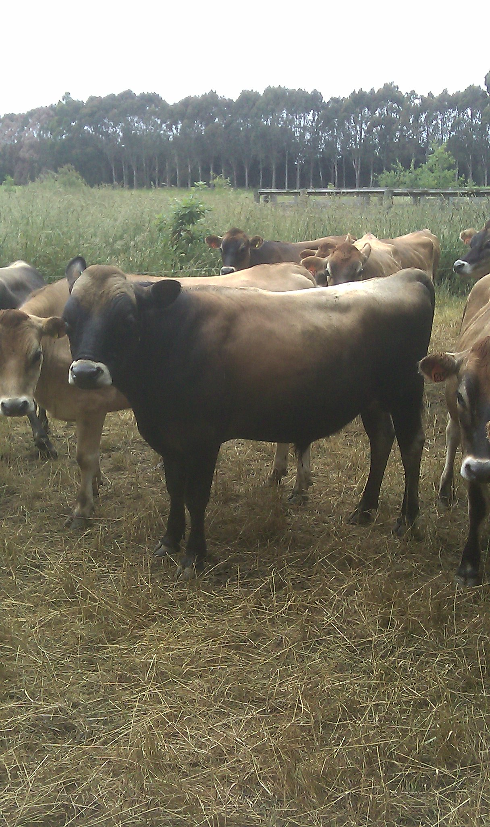

There are about 700 one and two year old bulls available this year for use over heifers; the balance not required for the grazing scheme available for lease to other farmers

As part of the certification process all bulls

- Are Tb free
- BVD virus antigen negative
- Vaccinated against BVD; IBR and Leptospirosis
- Had testicles checked
- Up to specified mating weights and body condition
- Treated for Ticks to help protect against Thieleria
- Passed a health check

There are still just a few bulls available for general hire if anybody needs some tail up bulls or you have farmer friends that require bulls over heifers or their herds. To be in; be quick
Contact John Pickering 0274429608

WEANER GRAZING

Weaner grazing is not far away. We always have a limited amount of grazing available as it’s not easy to find suitable farms and farmers that can grow weaners well. Let John or Kay know your requirements asap

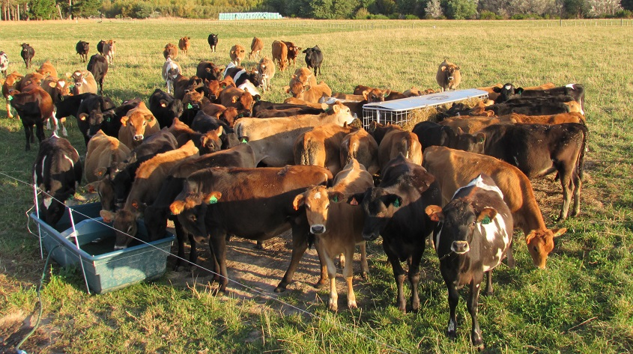

ROUND UP

Finally be assured the grazing team of John; Kay and soon Blake do care about the stock they are responsible for and know the need for them to grow to target and to get in calf to give the best return on investment possible and they do their best to manage this and give advice accordingly. Any concerns don’t hesitate to contact one of the team.

